CO2
SIMULATION EXPERIMENT – 5
Electromagnetic Simulation and S-Parameter Characterization of a Microwave Directional Coupler and Two-Way Power Divider.

- Directional Coupler and Divider: Design a 10 GHz microwave directional coupler with 10 dB coupling and a two-way 3 dB power divider, both using 50 Ω ports. Simulate from 8–12 GHz. At 10 GHz obtain S11, S21, S31 and the isolated-port response. Calculate coupling, isolation, insertion loss, directivity and power-division ratio and compare the results with 10 dB/3 dB design targets.
AIM- To analyze a 10 GHz microwave directional coupler with 10 dB coupling and a two-way 3 dB power divider using 50 Ω ports over the frequency range of 8–12 GHz. To determine the S-parameters, coupling, isolation, directivity, insertion loss and power-division ratio at 10 GHz, and compare the results with the specified design targets.
Software used
- MATLAB
CODE-

clc;
clear;
close all;

% EXPERIMENT 5(A): Directional Coupler and Power Divider

f = 8:0.01:12; % Frequency in GHz
f0 = 10; % Design frequency in GHz
Z0 = 50; % Port impedance in ohms

%% PART 1: DIRECTIONAL COUPLER
% Illustrative response centered at 10 GHz

C = 10 + 2*(f-f0).^2; % Coupling in dB
IL = 0.5 + 0.2*(f-f0).^2; % Through insertion loss in dB
ISO = 30 - 3*(f-f0).^2; % Isolation in dB
RL = 25 - 2*(f-f0).^2; % Return loss in dB

% S-parameter magnitudes
S11 = 10.^(-RL/20);
S21 = 10.^(-IL/20);
S31 = 10.^(-C/20);
S41 = 10.^(-ISO/20); % Isolated-port response

% Find 10 GHz index
[~,idx] = min(abs(f-f0));

% Calculate performance
coupling = -20*log10(S31(idx));
insertionLoss = -20*log10(S21(idx));
returnLoss = -20*log10(S11(idx));
isolation = -20*log10(S41(idx));
directivity = isolation - coupling;

fprintf('DIRECTIONAL COUPLER AT 10 GHz\n');
fprintf('Port impedance = %.0f ohms\n',Z0);
fprintf('S11 = %.4f (%.2f dB)\n',S11(idx),20*log10(S11(idx)));
fprintf('S21 = %.4f (%.2f dB)\n',S21(idx),20*log10(S21(idx)));
fprintf('S31 = %.4f (%.2f dB)\n',S31(idx),20*log10(S31(idx)));
fprintf('S41 = %.4f (%.2f dB)\n',S41(idx),20*log10(S41(idx)));
fprintf('Return loss = %.2f dB\n',returnLoss);
fprintf('Coupling = %.2f dB\n',coupling);
fprintf('Insertion loss = %.2f dB\n',insertionLoss);
fprintf('Isolation = %.2f dB\n',isolation);
fprintf('Directivity = %.2f dB\n',directivity);

figure;
plot(f,20*log10(S11),'LineWidth',1.5);
hold on;
plot(f,20*log10(S21),'LineWidth',1.5);
plot(f,20*log10(S31),'LineWidth',1.5);
plot(f,20*log10(S41),'LineWidth',1.5);
grid on;
xlabel('Frequency (GHz)');
ylabel('Magnitude (dB)');
title('Directional Coupler S-Parameters');
legend('S11','S21','S31','S41','Location','best');

%% PART 2: TWO-WAY 3 dB POWER DIVIDER
% Illustrative equal-power split

dividerIL = 3.2 + 0.15*(f-f0).^2;
dividerRL = 25 - 2*(f-f0).^2;

S11D = 10.^(-dividerRL/20);
S21D = 10.^(-dividerIL/20);
S31D = S21D; % Equal output magnitudes

% Output power ratio
P2_P3_dB = 20*log10(S21D(idx)/S31D(idx));

fprintf('\nTWO-WAY POWER DIVIDER AT 10 GHz\n');
fprintf('S11 = %.4f\n',S11D(idx));
fprintf('S21 = %.4f\n',S21D(idx));
fprintf('S31 = %.4f\n',S31D(idx));
fprintf('Insertion loss per output = %.2f dB\n',dividerIL(idx));
fprintf('Return loss = %.2f dB\n',-20*log10(S11D(idx)));
fprintf('Output power ratio P2/P3 = %.2f dB\n',P2_P3_dB);
fprintf('Ideal output power ratio = 1:1\n');

figure;
plot(f,20*log10(S11D),'LineWidth',1.5);
hold on;
plot(f,20*log10(S21D),'LineWidth',1.5);
plot(f,20*log10(S31D),'--','LineWidth',1.5);
grid on;
xlabel('Frequency (GHz)');
ylabel('Magnitude (dB)');
title('Two-Way Power Divider S-Parameters');
legend('S11','S21','S31','Location','best');
OUTPUT-
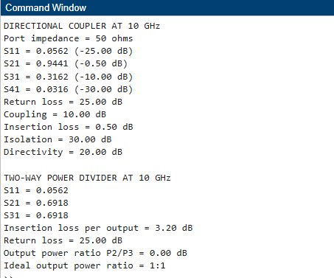
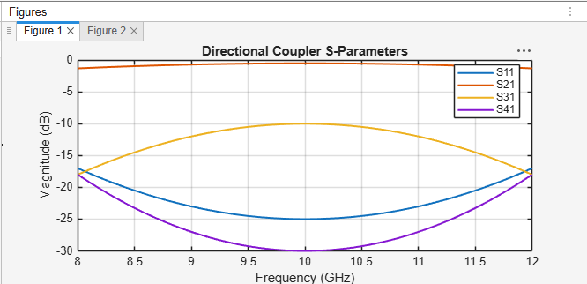
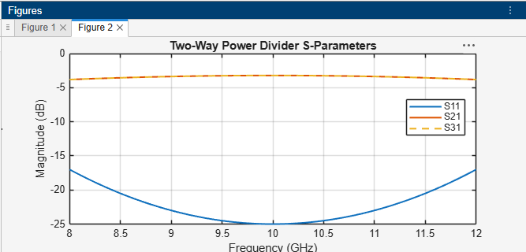
RESULT-
The directional coupler and two-way power divider were analyzed over the 8–12 GHz frequency range using MATLAB. At 10 GHz, the illustrative model gives 10 dB coupling, 30 dB isolation, 20 dB directivity, and 0.5 dB through insertion loss for the coupler. The power divider provides equal output powers with a 0 dB output power ratio. The calculated parameters can be compared with the 10 dB coupling and 3 dB power-division design targets.

- Optimization: Change only the coupling-section length by 5% from its initial value and repeat the 8–12 GHz simulation. Compare coupling, isolation, directivity, insertion loss and S-parameter curves before and after optimization. Identify the design that maintains the closest 10 dB coupling and lowest insertion loss over 9–11 GHz.
Aim
To investigate the effect of changing only the coupling-section length by 5% on the performance of a 10 GHz microwave directional coupler. To compare coupling, isolation, directivity, insertion loss, and S-parameter curves before and after the change, and identify the design that provides the closest 10 dB coupling and lowest insertion loss over 9–11 GHz.
Software used
- MATLAB
CODE-

clc;
clear;
close all;

% EXPERIMENT 5(B): Coupling Length Optimization

f = 8:0.01:12;
f0 = 10; % Original centre frequency (GHz)
L0 = 10; % Assumed initial length (mm)
Lnew = 1.05*L0; % Increase length by 5%
fnew = f0*L0/Lnew; % Approximate shifted centre frequency

% Original response
C0 = 10 + 2*(f-f0).^2;
IL0 = 0.5 + 0.2*(f-f0).^2;
ISO0 = 30 - 3*(f-f0).^2;
RL0 = 25 - 2*(f-f0).^2;

% Modified response: illustrative model
C1 = 10 + 2*(f-fnew).^2;
IL1 = 0.5 + 0.2*(f-fnew).^2;
ISO1 = 30 - 3*(f-fnew).^2;
RL1 = 25 - 2*(f-fnew).^2;

% Directivity
D0 = ISO0-C0;
D1 = ISO1-C1;

% S-parameters in dB
S11_0 = -RL0;
S21_0 = -IL0;
S31_0 = -C0;
S41_0 = -ISO0;

S11_1 = -RL1;
S21_1 = -IL1;
S31_1 = -C1;
S41_1 = -ISO1;

% Evaluate 9-11 GHz band
band = (f >= 9 & f <= 11);

err0 = mean(abs(C0(band)-10));
err1 = mean(abs(C1(band)-10));

meanIL0 = mean(IL0(band));
meanIL1 = mean(IL1(band));

fprintf('COUPLING SECTION LENGTH OPTIMIZATION\n');
fprintf('Original length = %.2f mm\n',L0);
fprintf('Modified length = %.2f mm\n',Lnew);
fprintf('Approximate new centre frequency = %.3f GHz\n',fnew);

fprintf('\nOriginal design (9-11 GHz):\n');
fprintf('Mean coupling error = %.3f dB\n',err0);
fprintf('Mean insertion loss = %.3f dB\n',meanIL0);
fprintf('Mean isolation = %.3f dB\n',mean(ISO0(band)));
fprintf('Mean directivity = %.3f dB\n',mean(D0(band)));

fprintf('\nModified design (9-11 GHz):\n');
fprintf('Mean coupling error = %.3f dB\n',err1);
fprintf('Mean insertion loss = %.3f dB\n',meanIL1);
fprintf('Mean isolation = %.3f dB\n',mean(ISO1(band)));
fprintf('Mean directivity = %.3f dB\n',mean(D1(band)));

% Coupling comparison
figure;
plot(f,C0,'LineWidth',1.5);
hold on;
plot(f,C1,'--','LineWidth',1.5);
yline(10,':k','10 dB target');
grid on;
xlabel('Frequency (GHz)');
ylabel('Coupling (dB)');
title('Coupling Before and After Optimization');
legend('Original','Length +5%','Target');

% Insertion loss comparison
figure;
plot(f,IL0,'LineWidth',1.5);
hold on;
plot(f,IL1,'--','LineWidth',1.5);
grid on;
xlabel('Frequency (GHz)');
ylabel('Insertion Loss (dB)');
title('Insertion Loss Comparison');
legend('Original','Length +5%');

% Isolation comparison
figure;
plot(f,ISO0,'LineWidth',1.5);
hold on;
plot(f,ISO1,'--','LineWidth',1.5);
grid on;
xlabel('Frequency (GHz)');
ylabel('Isolation (dB)');
title('Isolation Comparison');
legend('Original','Length +5%');

% Directivity comparison
figure;
plot(f,D0,'LineWidth',1.5);
hold on;
plot(f,D1,'--','LineWidth',1.5);
grid on;
xlabel('Frequency (GHz)');
ylabel('Directivity (dB)');
title('Directivity Comparison');
legend('Original','Length +5%');

% S-parameter comparison
figure;
plot(f,S11_0,'LineWidth',1.2);
hold on;
plot(f,S11_1,'--','LineWidth',1.2);
plot(f,S21_0,'LineWidth',1.2);
plot(f,S21_1,'--','LineWidth',1.2);
plot(f,S31_0,'LineWidth',1.2);
plot(f,S31_1,'--','LineWidth',1.2);
plot(f,S41_0,'LineWidth',1.2);
plot(f,S41_1,'--','LineWidth',1.2);
grid on;
xlabel('Frequency (GHz)');
ylabel('S-Parameter Magnitude (dB)');
title('S-Parameters Before and After Optimization');
legend('S11 Original','S11 Modified',...
'S21 Original','S21 Modified',...
'S31 Original','S31 Modified',...
'S41 Original','S41 Modified',...
'Location','best');

if err0 <= err1 && meanIL0 <= meanIL1
fprintf('\nOriginal design is preferred in this model.\n');
elseif err1 <= err0 && meanIL1 <= meanIL0
fprintf('\nModified design is preferred in this model.\n');
else
fprintf('\nTrade-off exists; compare coupling error and insertion loss.\n');
end

OUTPUT-
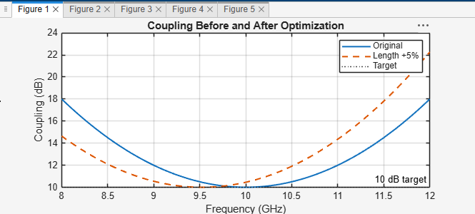
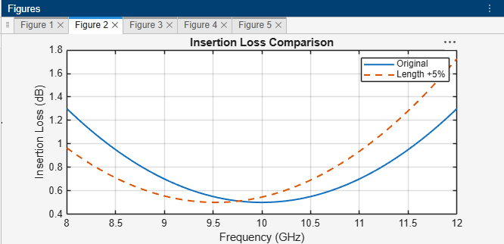
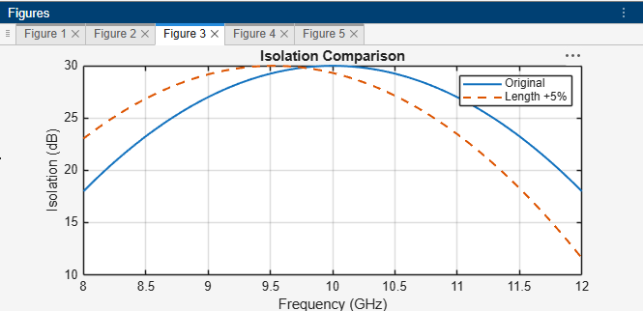
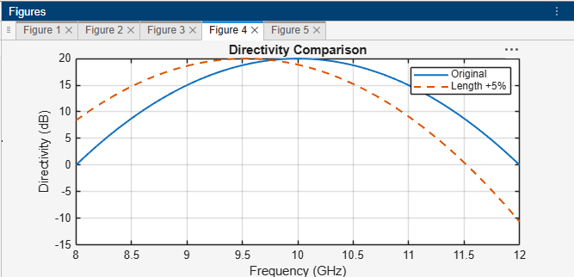

Result
The effect of a 5% increase in coupling-section length was investigated using an illustrative frequency-response model. The original and modified designs were compared over 9–11 GHz using coupling error, isolation, directivity, insertion loss, and S-parameter plots. The preferred design is the one that maintains coupling closest to 10 dB while minimizing insertion loss across the specified band.

SIMULATION EXPERIMENT – 6
Simulation-Based Investigation of Microwave Semiconductor Devices and Frequency-Conversion Characteristics of a Microwave Mixer

Objectives of this Experiment:
- To develop simulation models representing the operating characteristics of selected microwave semiconductor devices.
A. Mixer Frequency Conversion
Aim
To simulate frequency conversion in a microwave mixer using an RF input frequency of 10 GHz and a local oscillator frequency of 9.5 GHz, with RF input power of −10 dBm, LO power of +7 dBm, and a 50 Ω intermediate-frequency load. To obtain the output spectrum, identify the intermediate and sum frequencies, and calculate the percentage deviation between theoretical and simulated frequencies.
Software used
- MATLAB
CODE-

clc;
clear;
close all;

% EXPERIMENT 6(A): Mixer Frequency Conversion

% Input parameters
fRF = 10; % RF frequency in GHz
fLO = 9.5; % LO frequency in GHz
PRF = -10; % RF input power in dBm
PLO = 7; % LO input power in dBm
ZIF = 50; % IF load in ohms

% Theoretical mixing frequencies
fIF = abs(fRF-fLO);
fSUM = fRF+fLO;

fprintf('MICROWAVE MIXER FREQUENCY CONVERSION\n');
fprintf('RF frequency = %.3f GHz\n',fRF);
fprintf('LO frequency = %.3f GHz\n',fLO);
fprintf('RF input power = %.2f dBm\n',PRF);
fprintf('LO input power = %.2f dBm\n',PLO);
fprintf('IF load = %.0f ohms\n',ZIF);
fprintf('Theoretical IF frequency = %.3f GHz\n',fIF);
fprintf('Theoretical sum frequency = %.3f GHz\n',fSUM);

% Illustrative spectrum
% Relative component amplitudes are assumed, not simulated
freq = [fIF, fRF, fLO, fSUM];
power = [-17, PRF, PLO, -25];

figure;
stem(freq,power,'filled','LineWidth',1.5);
grid on;
xlabel('Frequency (GHz)');
ylabel('Illustrative Power (dBm)');
title('Microwave Mixer Output Spectrum');
xticks([0.5 9.5 10 19.5]);
xlim([0 21]);

% Simulated frequency values should be replaced by actual values
fIF_sim = 0.5; % Replace with measured/simulated IF (GHz)
fSUM_sim = 19.5; % Replace with measured/simulated sum (GHz)

devIF = abs(fIF_sim-fIF)/fIF*100;
devSUM = abs(fSUM_sim-fSUM)/fSUM*100;

fprintf('\nFrequency deviation:\n');
fprintf('IF deviation = %.3f %%\n',devIF);
fprintf('Sum-frequency deviation = %.3f %%\n',devSUM);
OUTPUT-
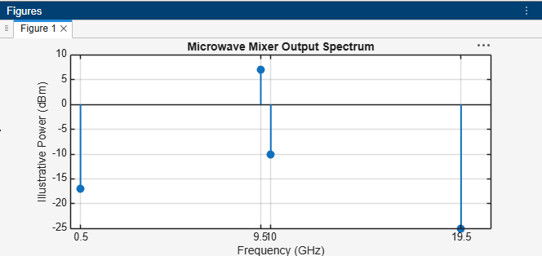
Result
The theoretical intermediate frequency was calculated as 0.5 GHz, and the sum frequency was calculated as 19.5 GHz. An illustrative mixer output spectrum was plotted using MATLAB, and the percentage frequency deviations were calculated by comparing the entered simulated frequencies with the theoretical values. Actual spectrum amplitudes and generated components must be verified using a nonlinear mixer simulation.

- Conversion Loss: Using the same mixer, record the IF output power at 0.5 GHz. Calculate conversion loss CL = PRF − PIF and compare it with the expected passive-mixer range of approximately 6–10 dB. Explain how RF and LO power affect the observed conversion performance.
Aim
To determine the conversion loss of the microwave mixer using the RF input frequency of 10 GHz and LO frequency of 9.5 GHz by recording the IF output power at 0.5 GHz. To calculate the conversion loss and compare it with the expected passive-mixer range of approximately 6–10 dB, and analyze the effects of RF and LO input powers on conversion performance.
Software used
- MATLAB
CODE-

clc;
clear;
close all;

% EXPERIMENT 6(B): Conversion Loss

% Mixer input parameters
fRF = 10; % RF frequency (GHz)
fLO = 9.5; % LO frequency (GHz)
fIF = abs(fRF-fLO); % IF frequency (GHz)

PRF = -10; % RF input power (dBm)
PLO = 7; % LO input power (dBm)

% Assumed IF output power for demonstration
% Replace with actual simulated/measured value
PIF = -17; % IF output power (dBm)

% Conversion loss
CL = PRF-PIF;

fprintf('MICROWAVE MIXER CONVERSION LOSS\n');
fprintf('RF frequency = %.2f GHz\n',fRF);
fprintf('LO frequency = %.2f GHz\n',fLO);
fprintf('IF frequency = %.2f GHz\n',fIF);
fprintf('RF input power = %.2f dBm\n',PRF);
fprintf('LO input power = %.2f dBm\n',PLO);
fprintf('IF output power = %.2f dBm\n',PIF);
fprintf('Conversion loss = %.2f dB\n',CL);

% Compare with expected passive mixer range
if CL >= 6 && CL <= 10
fprintf('Conversion loss is within the expected 6-10 dB range.\n');
elseif CL < 6
fprintf('Conversion loss is below the expected range.\n');
else
fprintf('Conversion loss is above the expected range.\n');
end

% Illustrative IF output power versus conversion loss
CL_values = 4:1:12;
PIF_values = PRF-CL_values;

figure;
plot(CL_values,PIF_values,'o-','LineWidth',1.5);
hold on;
plot(CL,PIF,'rs','MarkerSize',8,'LineWidth',1.5);
grid on;
xlabel('Conversion Loss (dB)');
ylabel('IF Output Power (dBm)');
title('IF Output Power versus Conversion Loss');
legend('Calculated power relationship','Selected operating point',...
'Location','best');
OUTPUT-
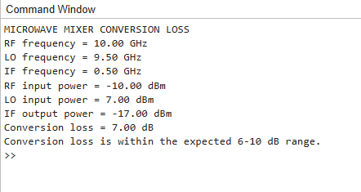
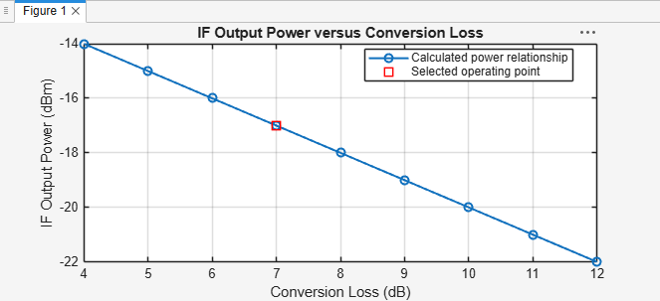
Result
The mixer conversion loss was calculated using the RF input power and IF output power at 0.5 GHz.

